Autonomous Driving: Driver Assistance/Training Module #2

*Sensor & pixy cam*

Jingwen Mo

Supervised by Prof. Quoc-Viet Dang

July 10th, 2018

# Introduction

Pixy is a fast vision sensor for DIY robotics and similar applications. You can teach Pixy an object just by pressing a button. When we can connect it to Arduino, we can do a lot of staff. We use Pixy cam to watch an orange object. If it gets close to our vehicle, we can open the ultrasonic sensor to detect the distance between the object and our vehicle which tells us whether we are close or too far away. This approach prevents the effects of interference on the sensor, which has many practical applications.

# Testing Environment

I have set 3 positive test cases and 3 negative test cases for driver assistance/training module

## Acceptable situation

### Green light test

When the object is standing and very close to our vehicle ( less than 10 cm), the ultrasonic sensor will sense the distance and turn the green light on.

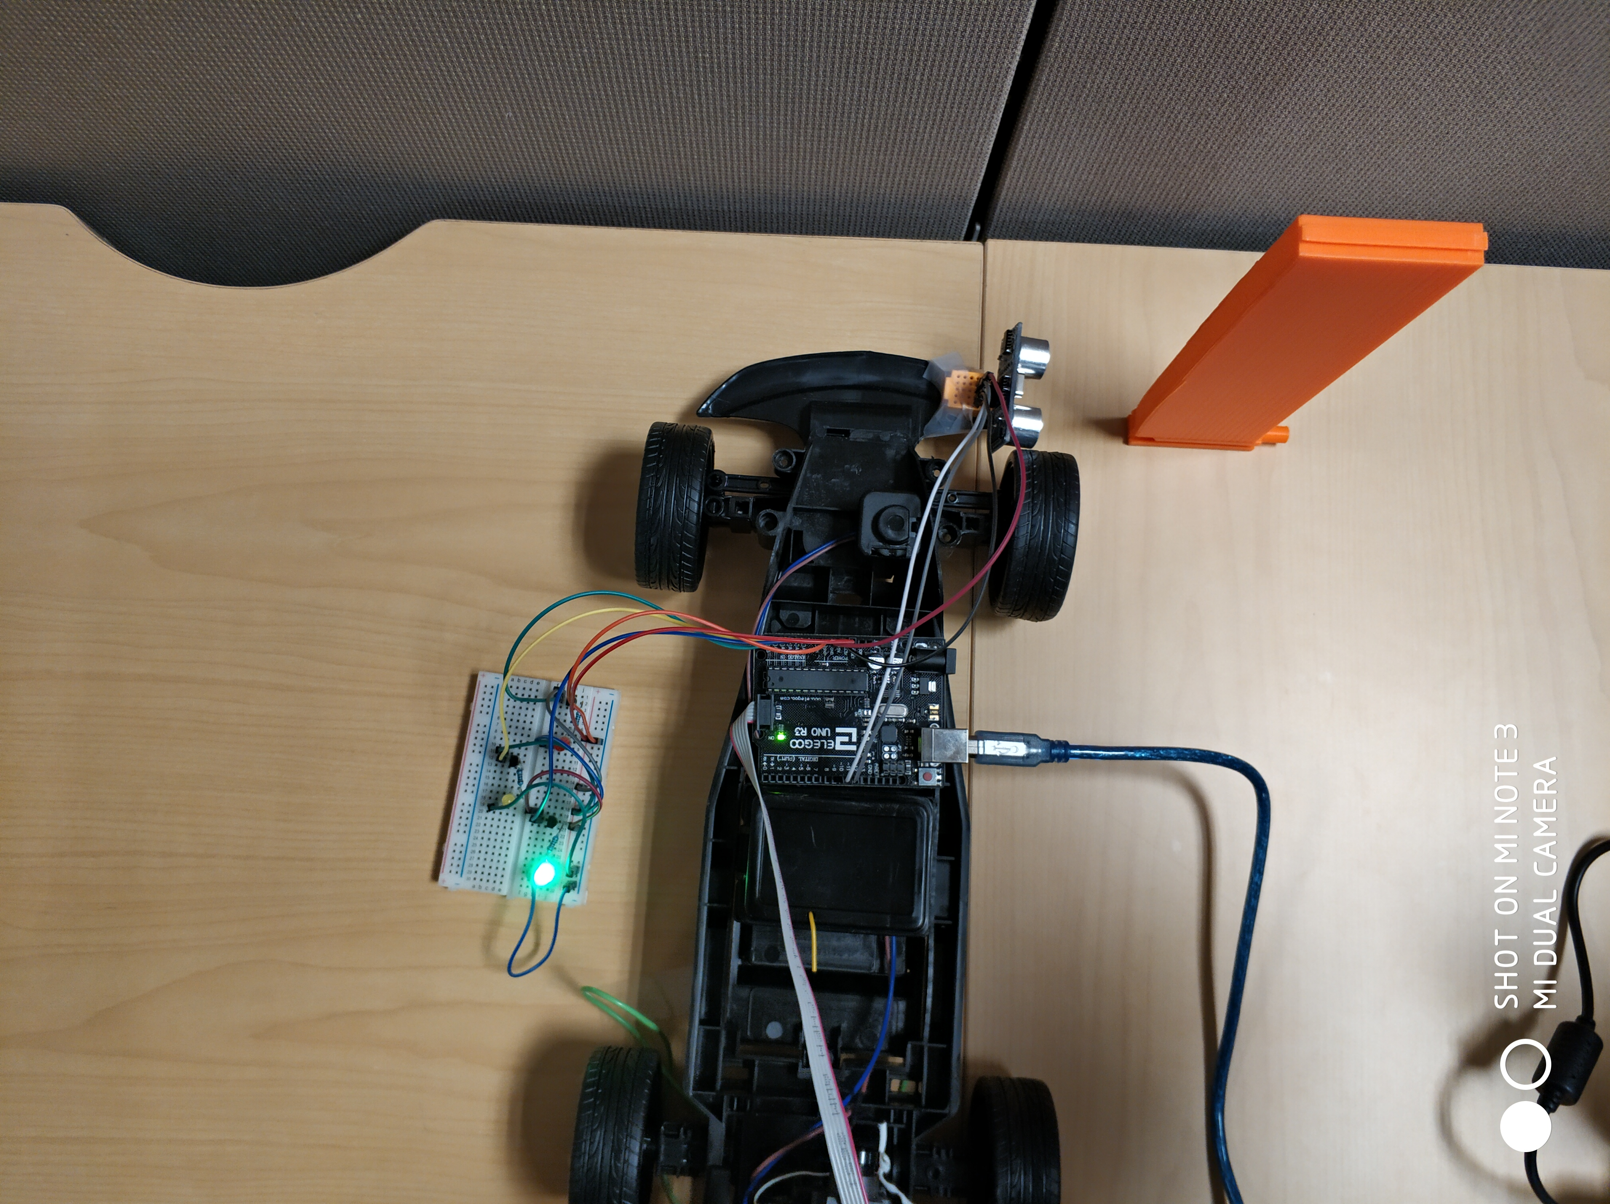

We can see that the distance is around 7cm,

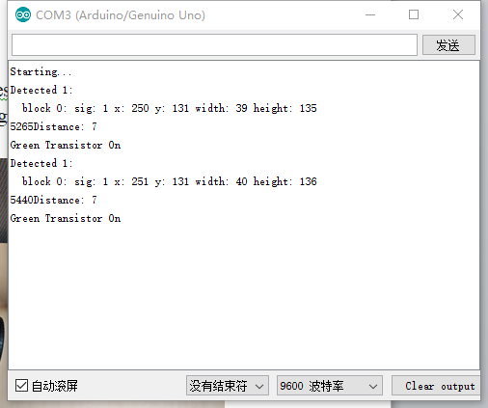

terminal output-GL

And this is what pixy sees.

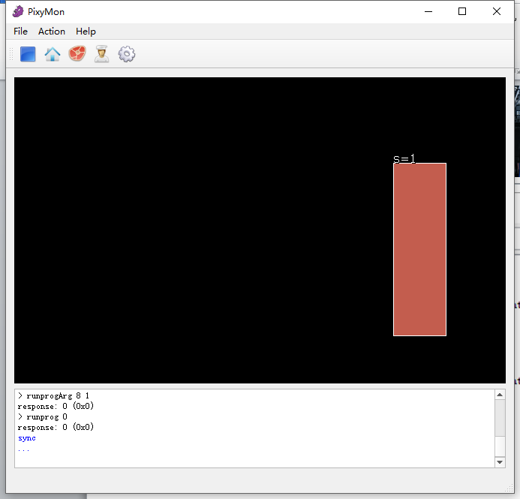

Pixy cam vision-GL

### Yellow light test

When the object is standing and close to our vehicle( less than 30 cm and more than 10 cm), the ultrasonic sensor will sense the distance and turn the yellow light on.

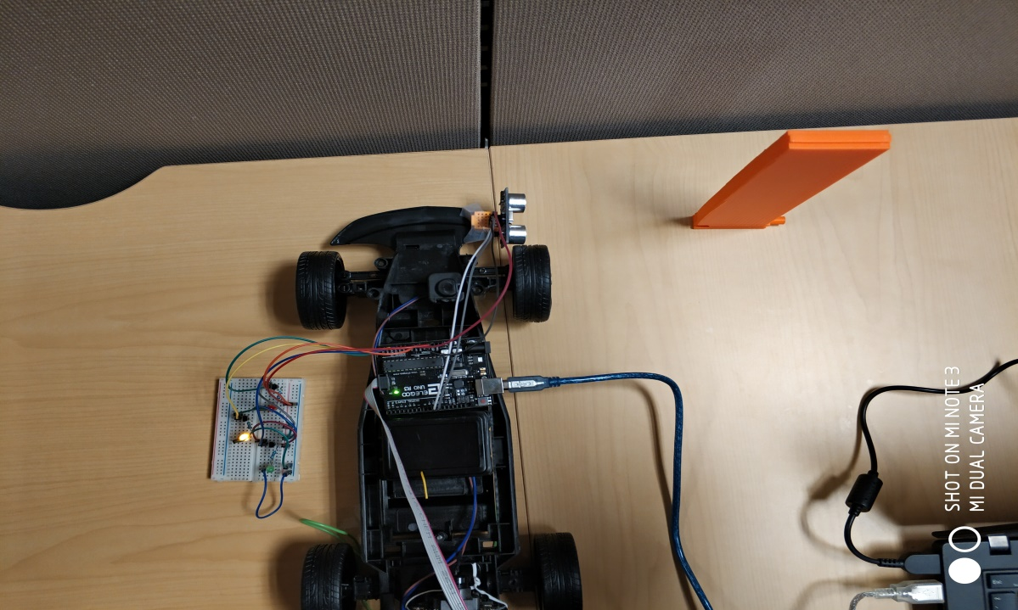

We can see that the distance is around 16cm,

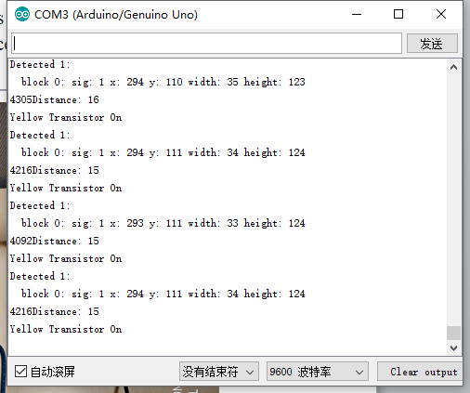

terminal output-YL

And this is what pixy sees.

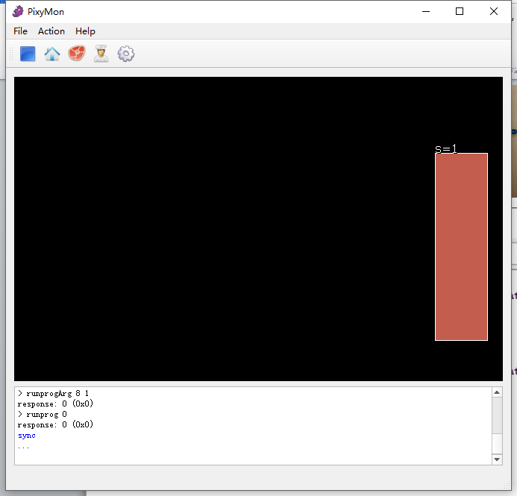

Pixy cam vision-YL

### Red light

Theoretically, when the object is a little far from our vehicle( more than 30 cm and less than 60 cm), the red light will be turned on. However, due to the limitation of the pixy cam vision scope, which I will talk about later, this cannot work. In order to show you how this system works, I rearrange the 3 different ranges (0 to 6: Green light; 7 to 12: Yellow light; 13 to 19: Red light).

After this change, we can see that red light is turned on when the distance is 14cm

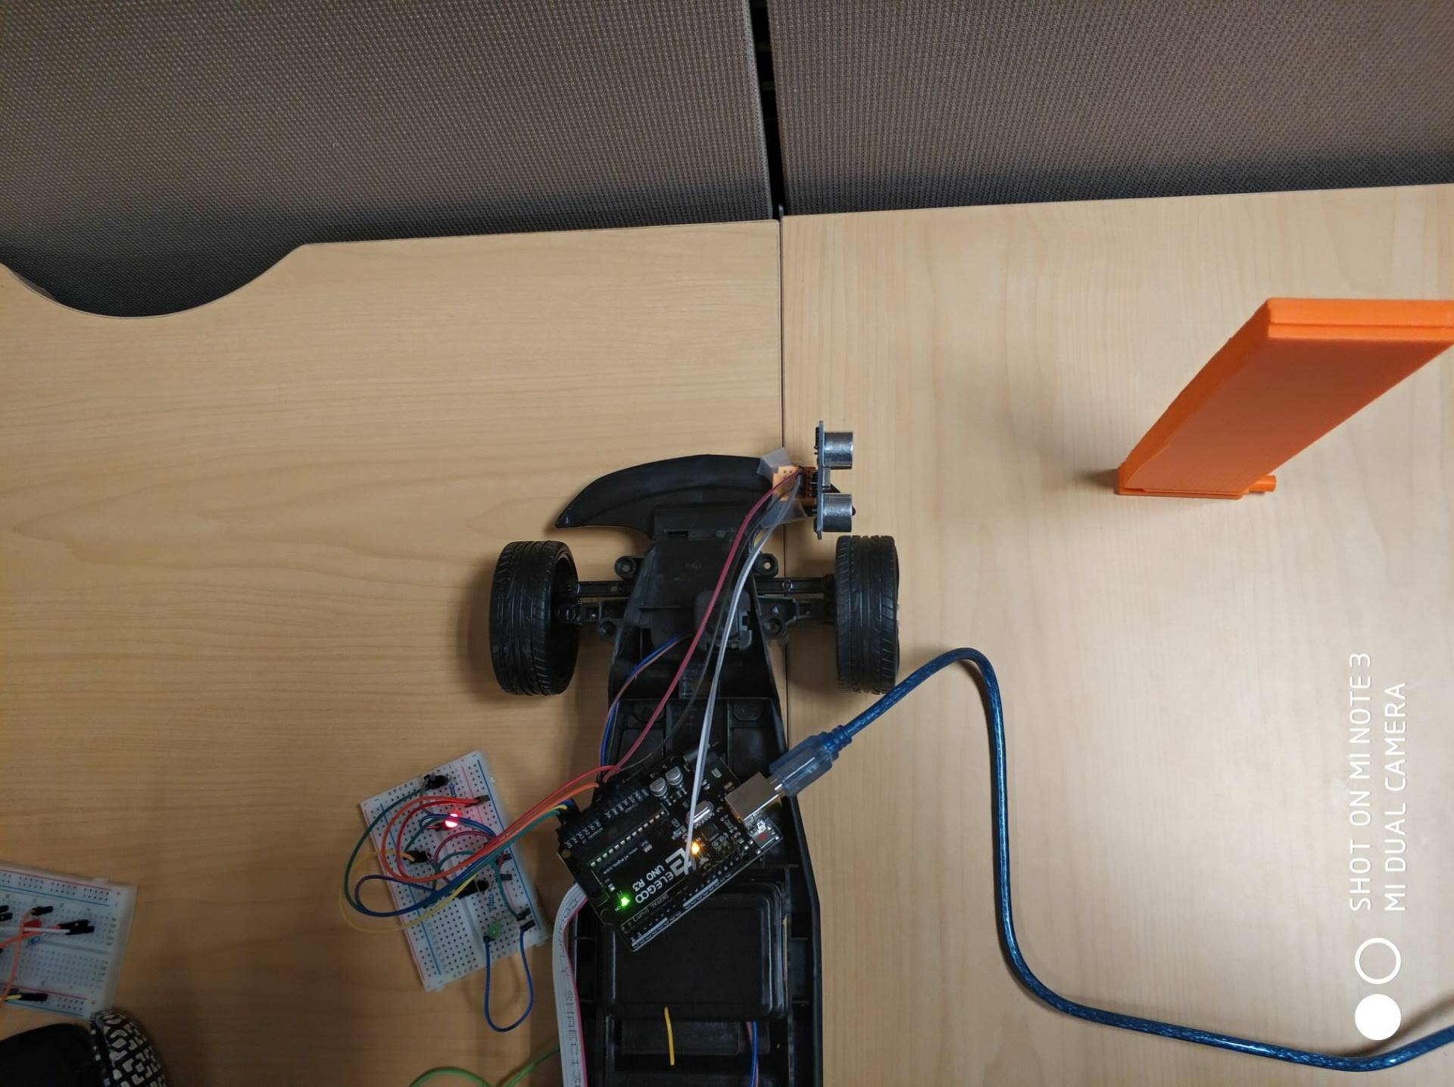

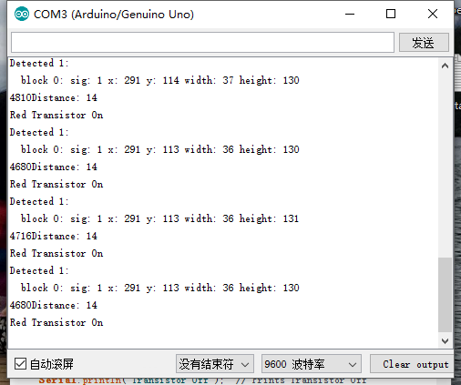

terminal output-RL

this is what pixy sees.

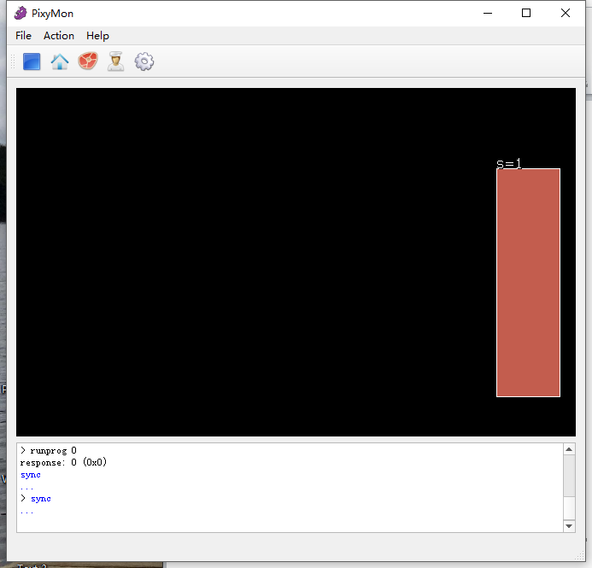

Pixy cam vision-RL

## edge situation

When the distance is greater than 19cm, the object moves out of the field of vision of the camera as shown below, in this situation, it will cause bugs and no light will be turned on.

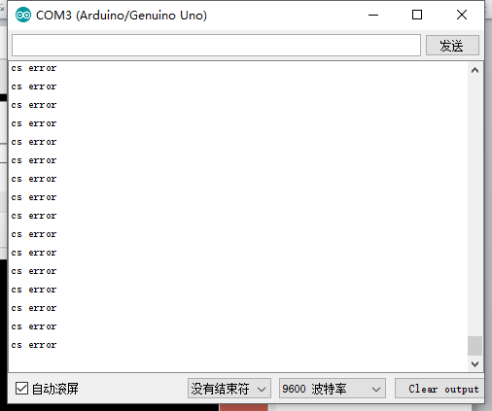

terminal output when >19cm

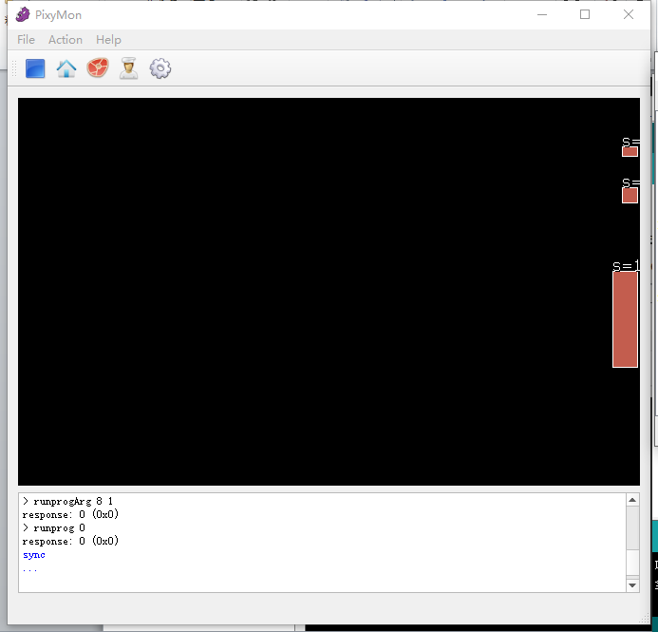

Pixy cam vision when >19cm

When the object moves out of vision totally, the sensor will not record anything.

This is the edge situation, when the distance is equal to 19cm.This is totally ok and the yellow light will be turned on.

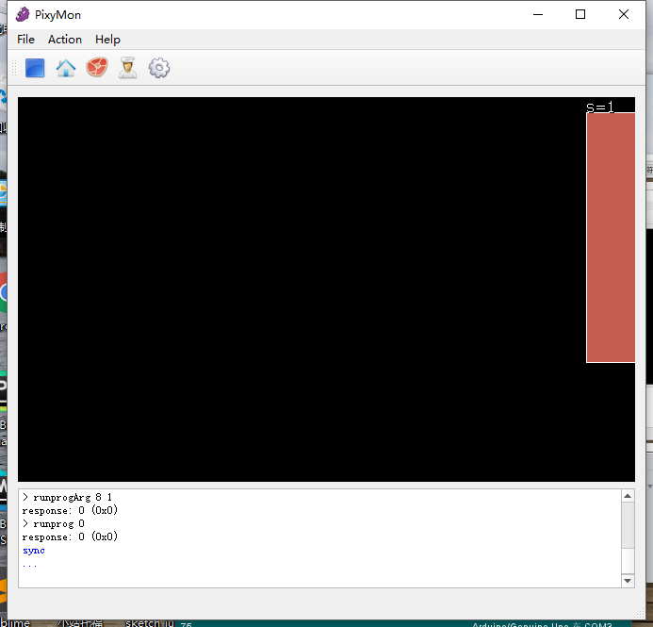

This is the screenshot of the terminal showing the distance output in text.

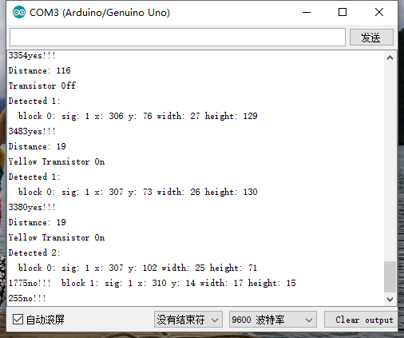

## no recording situation

We can see that the Pixy cam does detect the orange object, at the meanwhile, we put a green object in front of the sensor. The sensor does not open and no light is turned on just as what we think before.

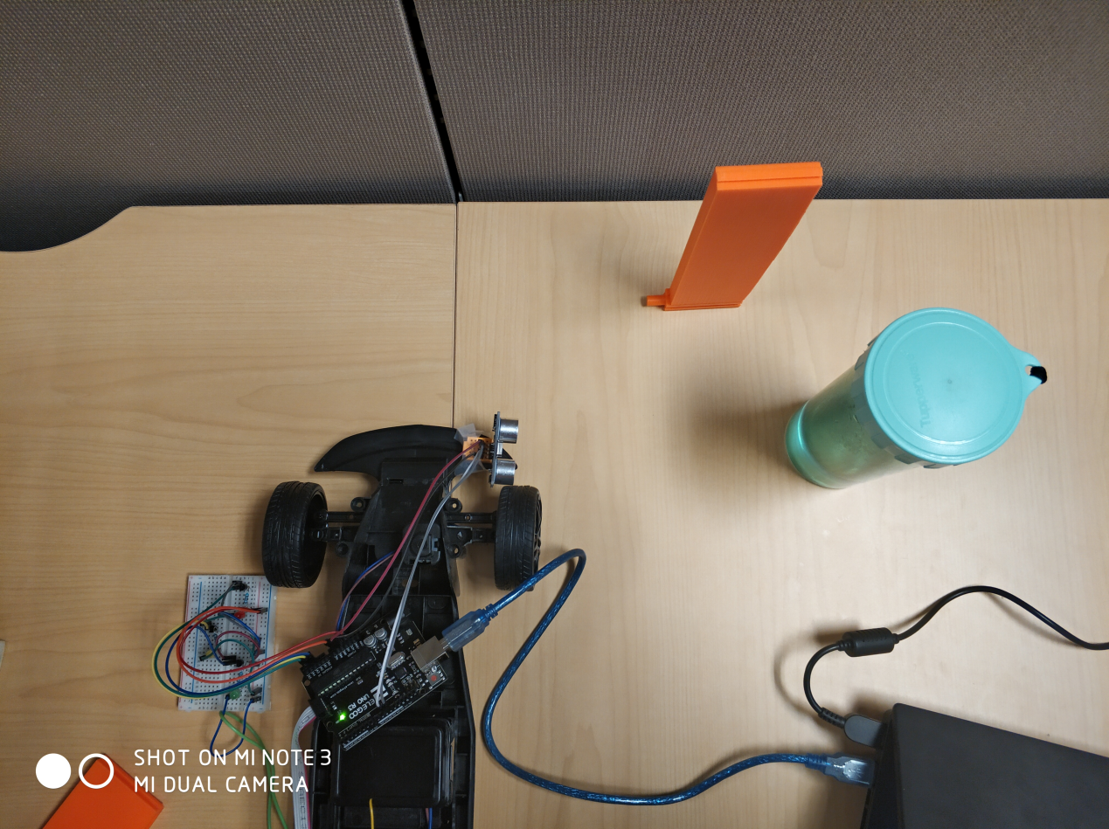

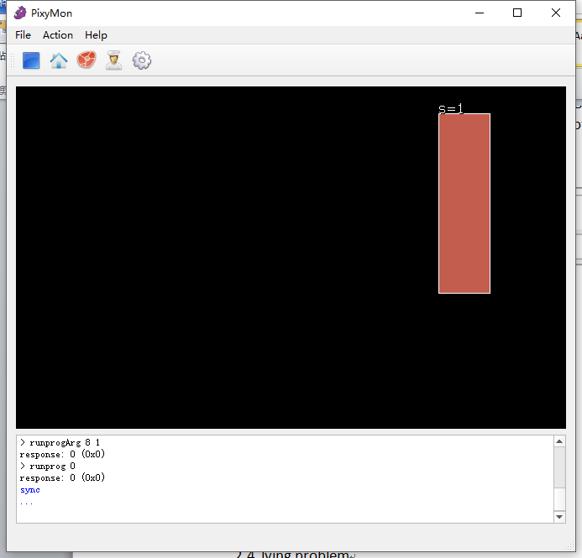

Pixy cam vision

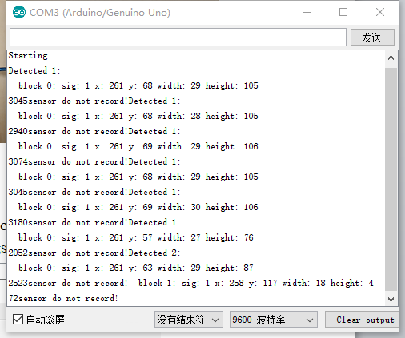

terminal output

## lying object situation

Our system can ignore the lying object and only detect the standing object. When the orange object is lying, the pixy cam can detect it but do not open the sensor and no light is turned on.

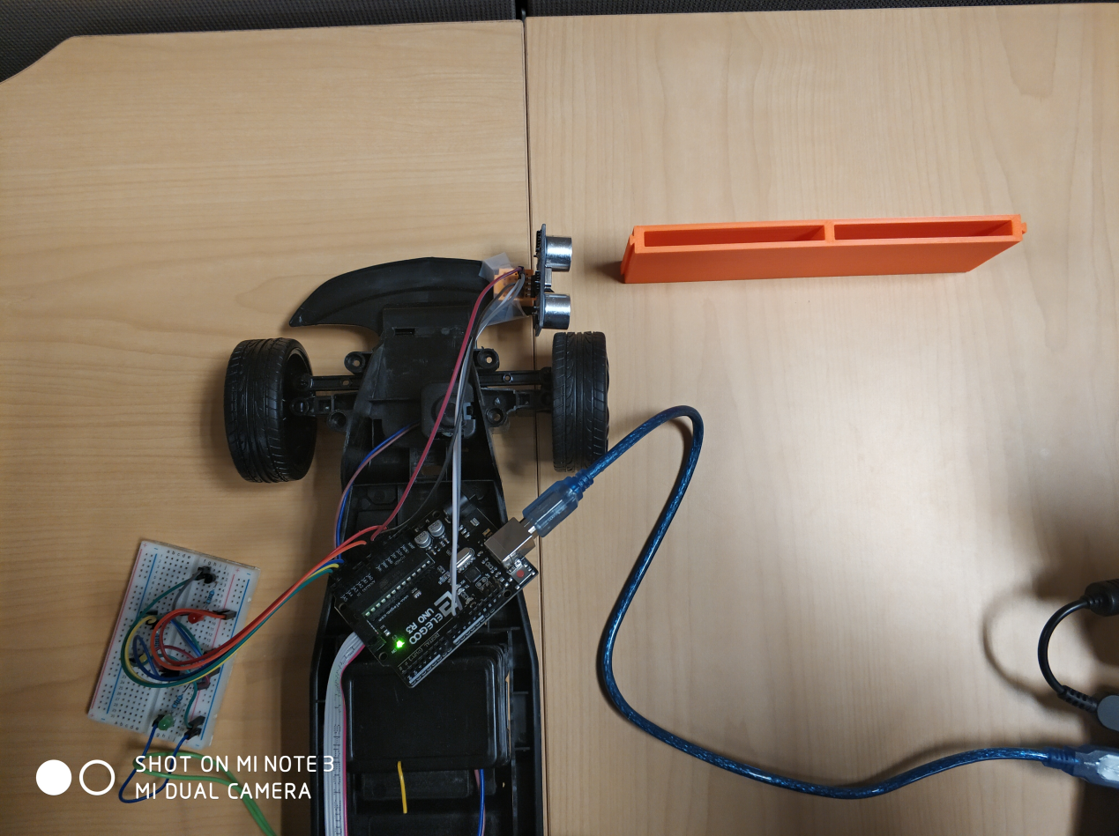

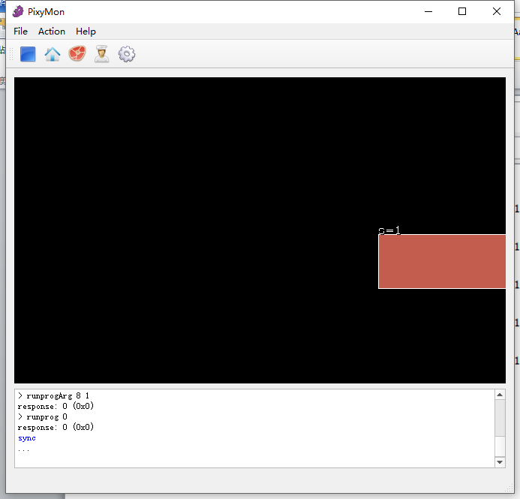

Pixy cam vision of the lying object

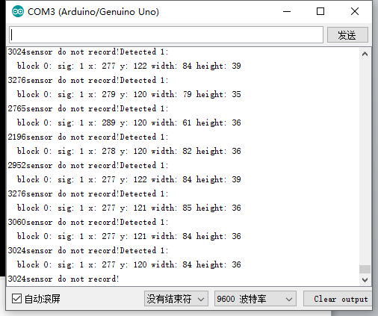

terminal output

## slow speed

In reality, we usually need to control the car with a remote control. So we remove our car from laptop, plug in battery for Arduino & pixy cam, and move slowly for testing. We must pay attention to the voltage and current of the battery due to the requirement of the pixy cam.

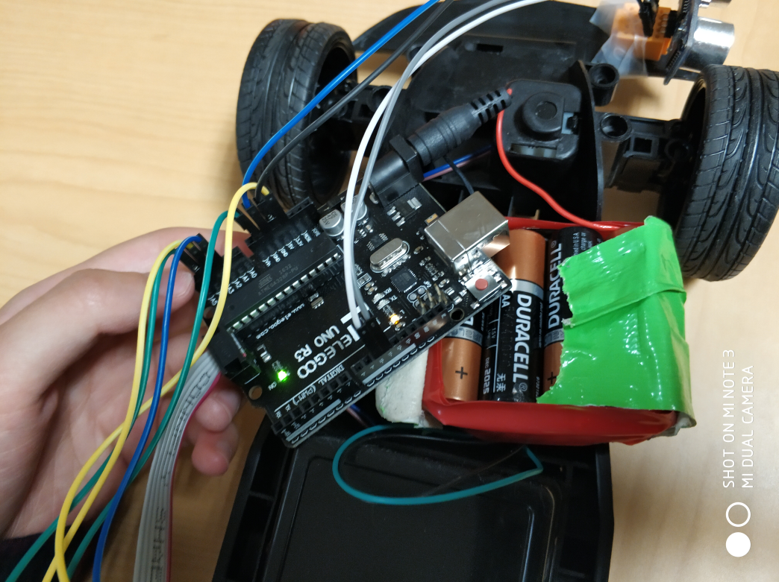

### indoors

- The sensor-only version:

When only ultrasonic sensor is used, the vehicle will detect every object in front of the sensor, including the green one, the lying orange one and the standing orange one. But in fact, the standing orange one is exactly what we wanted.

The result is just as we expected before. When the vehicle passes by the green object(>30), the red light is turned on; When the vehicle passes by the lying orange object(>10), the yellow light is turned on; When the vehicle passes by the standing orange object(<10), the green light is turned on.

Here is the video you can check out: https://youtu.be/RkFsnnPd6l8

- Sensor & pixy cam version:

When we use both ultrasonic sensor and pixy cam, we can get what we wanted. Our system will only detect the standing orange object.

The result is just as we expected before. When the vehicle passes by the green object(>30), no light is turned on; When the vehicle passes by the lying orange object(>10), no light is turned on; When the vehicle passes by the standing orange object(<10), the green light is turned on.

Here is the video you can check out: https://youtu.be/G47z_ybvn7o

### outdoors

Because the light is different outdoors, so we have to remark our object in the pixy cam outdoors.

The experiment time is 10:30 am on a regular sunny day.

The result is just as we expected before. When the vehicle passes by the green object(>30), no light is turned on; When the vehicle passes by the lying orange object(>10), no light is turned on; When the vehicle passes by the standing orange object(<10), the green light is turned on.

Here is the video you can check out: https://youtu.be/VU7BhJCIXPA

## high speed

When the car moves in a relatively high speed, we have to remove all the time delays in our code. Also, things are getting more complicated when our car moves really fast, especially faster than the frame rate of the pixy cam, we might miss the orange object we wanted. Due to the limitation of our equipment, we have to make a little change in our code. We begin to record distance earlier, of course, doing so can cause noise in our record, which we will deal with later on.

### Indoors

When the vehicle passes by the green object(>30), no light is turned on; When the vehicle passes by the lying orange object(>10), no light is turned on; When the vehicle passes by the standing orange object(<10), the green light is turned on.

Here is the video you can check out: https://youtu.be/aIIRxuLfQ6Q

### outdoors

The experiment time is 10:30 am on a regular sunny day.

When the vehicle passes by the green object(>30), no light is turned on; When the vehicle passes by the lying orange object(>10), no light is turned on; When the vehicle passes by the standing orange object(<10), the green light is turned on. However, because the outdoor lighting is too strong, the result is not very easy to observe.

Here is the video you can check out: https://youtu.be/3wPVkrguQmc

# CONCLUSION AND FUTURE WORK

This project works toward autonomous driving in a racing environment through a driver assistance/training module. For this prototype, I mix ultrasonic sensor with pixy cam. We use Pixy cam to watch an orange object. If it gets close to our vehicle, we can open the ultrasonic sensor to detect the distance between the object and our vehicle, which tells us whether we are close or too far away, while preventing the effects of interference on the sensor.

In order to achieve the goal, I have set 3 positive test cases and 3 negative test cases. Firstly, I tested every light separately and it works just fine for Green and yellow light. Due to the limitation of the pixy cam, the object moves out of the field of vision of the camera when the distance is greater than 19cm. In this situation (>19)no light will turned on. Also, I test the lying orange object situation and object in another color(e.g. green). It works in the situation above and no light is turned on. Furthermore, I test both slow speed and high speed as well as indoors and outdoors. It works just as we expected, the green light is only turned on when it passes by the standing orange object (<10).

In the future work, I plan to change into another camera or change the position of the pixy cam. Because when the speed of the vehicle moves faster than the frame rate of the pixy cam, we might miss the orange object we wanted. With a more sophisticated camera and processor, we can do more experiments. For example, we can change into raspberry pi3 and we can detect more complicated object in more involved situations with the help of opencv and tensorflow.

# Reference

<https://pixycam.com/pixy-cmucam5/>

<http://www.deviceplus.com/how-tos/arduino-guide/an-intro-to-cmucam5-pixy-vision-camera-sensor/>

http://www.cmucam.org/projects/cmucam5/wiki/Hooking_up_Pixy_to_a_Microcontroller_(like_an_Arduino)